**Biography Of A Software Engineer – Dave Cutler**

*By Philip Healy*

*Prior to writing this essay, I would say I didn't know much about any specific software engineer. However, I came across one that left a lasting impression on me. Dave Cutler has made a very significant contribution to the technological world and the world of software engineering alike. If not for Cutler, our experience with computers on a daily basis may have been significantly different. From his early days at DuPont, his work with DEC, and most notably his time at Microsoft, Dave Cutler’s legacy is remarkable and clear to all in the software engineering world*.

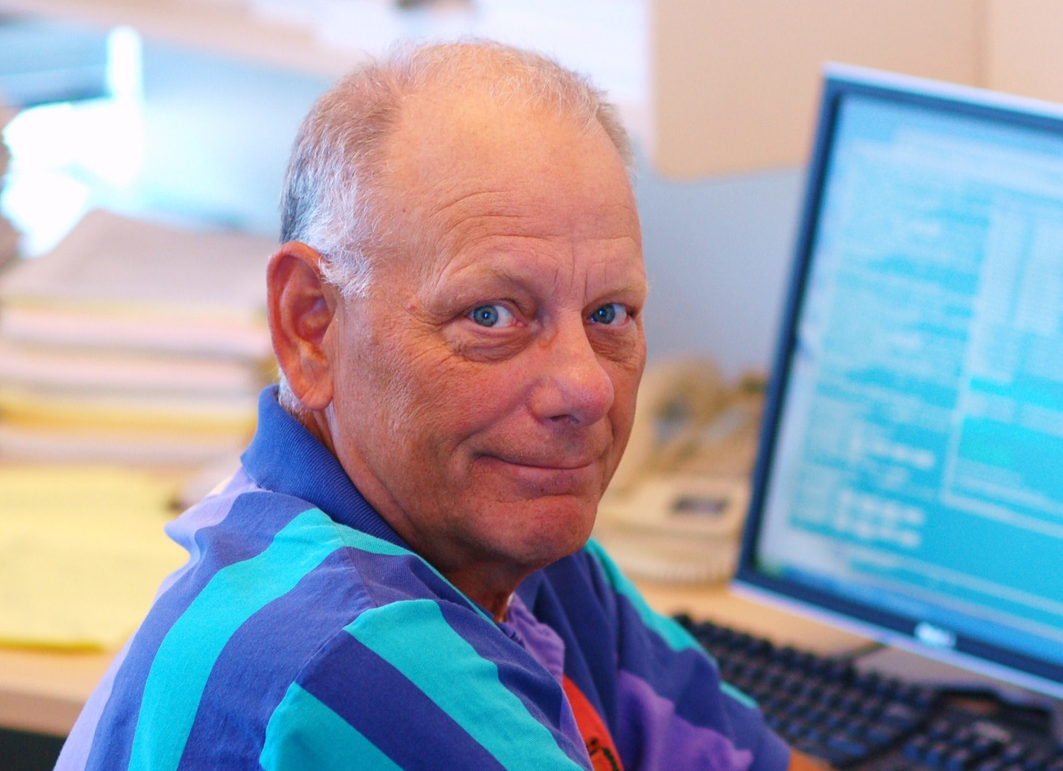

Dave Cutler grew up in Dewitt, Michigan. A promising American football player in his youth, Cutler was awarded a scholarship to Olivet College. After injuries cut his football career short, Cutler graduated with a bachelor’s degree in mathematics and physics.

He accepted a job at DuPont in 1965. At DuPont, Cutler was a technical writer and began programming real time process control systems. He was tasked with developing a model for Scott Paper Company’s new foam production process. Cutler learned a new language called GPSS-3 and used an IBM 7044 to build the model. There, he established his lifelong interest and career in software and digital operations.

In 1971, Cutler joined Digital Equipment Corporation (DEC) in Maynard, Massachusetts where he would develop a real time operating system, the RSX-11M , for the PDP-11 minicomputer. As per Gordon Bell, then DEC’s top engineering executive, sales of the PDP-11 were stagnating and IBM was on the verge of releasing its first minicomputer. The response was a 32-bit super minicomputer line of systems called the VAX. Cutler went on to lead the development and implementation of the VMS operating system for the VAX. He was the senior programmer of the VMS project. His work on VMS was groundbreaking and enabled VAX to become the category leader.

In 1982, due to frustrations management decisions, Cutler founded a DEC engineering lab in Bellevue, Washington. There, he and his team worked on successors to the VAX and VMS. They produced the MicroVAX and a real-time operating system called VAXeln. Cutler left DEC in 1988 after his team’s prism project was killed in favour of PMAX.

Cutler had been originally introduced to Bill Gates in 1983 by Gordon Bell and in 1988 he would join Microsoft to develop a new portable operating system – the beginning of Windows NT. Cutler started at Microsoft on October 31st, 1988. He brought a number of the DEC-West team with him. His team began by spending six months creating a specification for the operating system, which is now kept in the Smithsonian Institute.

The team started coding in April 1989 with the main goal of producing an operating system that was portable and available on multiple targets, could run on multiple operating systems, could run on systems with multiple processors and capable of running multiple programs at once.

Originally, the team was going to use the OS/2 32-bit API as the basis for the operating system. However, Windows 3.1 proved to be astronomically more popular than its predecessors, selling 16 million copies in six months. The team then decided to use Windows 32 for the system.

There were tough challenges, such as testing the system. The team didn't have the necessary resources to write a comprehensive test suite. Every night, the team ran stress tests on hundreds of machines. The system needed backwards compatibility. The team had to expand the Windows 16 API to Windows 32 API and redesign the entire graphics subsystem.

By the time the first version of Windows NT shipped, there were about 150 engineers on the team led by Cutler. There were only about 20 when the project first began. While clearly being a superb software engineer, Cutler was a brilliant leader. He was intense, crude and demanding at times. Nevertheless, he was very good at motivating people.

Cutler stopped managing the entire NT project in 1996 but continue to lead the kernel development until 2006. In 2005, he helped develop the AMD-64 architecture. He led the effort to ship the first two x64 Windows systems.

In 2008, Microsoft announced a technology preview of Windows Azure, which is a cloud-based operating system. Cutler developed the hypervisor and was a lead developer on the project. Azure now plays a significant role in Microsoft's cloud business. In 2011, Cutler wanted to learn more about the Xbox One, which needed a virtual machine in order for both games and apps to run on the console. Once he was shown plans for it, Cutler joined the team. He again designed and wrote the hypervisor for the Xbox One. Because there is a hypervisor, Xbox games can run on Windows and apps can run on the Xbox One. The impact of cutler's work on the Xbox One is phenomenal.

Outside of work, Cutler is an avid motor racing driver. I enjoyed this fact because it shows that successful people live their own lives too. He competed in the Atlantic championship from 1996 to 2002.

Cutler is one of the industry's most prominent and prolific engineers. He has advanced the computing industry and advanced business. Cutler's work on NT was directly responsible for enabling windows to yet again be the category killer. He is the key technical brain behind millions of lines of code constituting Windows. Steve Balmer noted that Cutler is an engineering leader with versatility, leadership and technical talents. He is the ultimate competitor who really wants to win. And he has won plenty of times.

Cutler is fanatical about quality. He ensures more than sufficient test code is written. He also ensures he understands the hardware. Even into his 70s, he still shows passion for his work. Ballmer believes there wouldn't be a Microsoft today without Cutler. Known as a doer, not a talker, he is separated from the rest. He is considered one of the greatest systems programmers of all time.

On a personal note, I find it fascinating that Cutler didn't necessarily know what he wanted to do when he had finished college. I was amazed to learn that he didn’t once work with a computer in his college years. Computer programming and software engineering were things that came to him out of chance, but he pursued a career in the field. I find it reassuring that even if I’m unsure about where my career will go, people have been in the same position. Dave Cutler was and he turned out just fine.

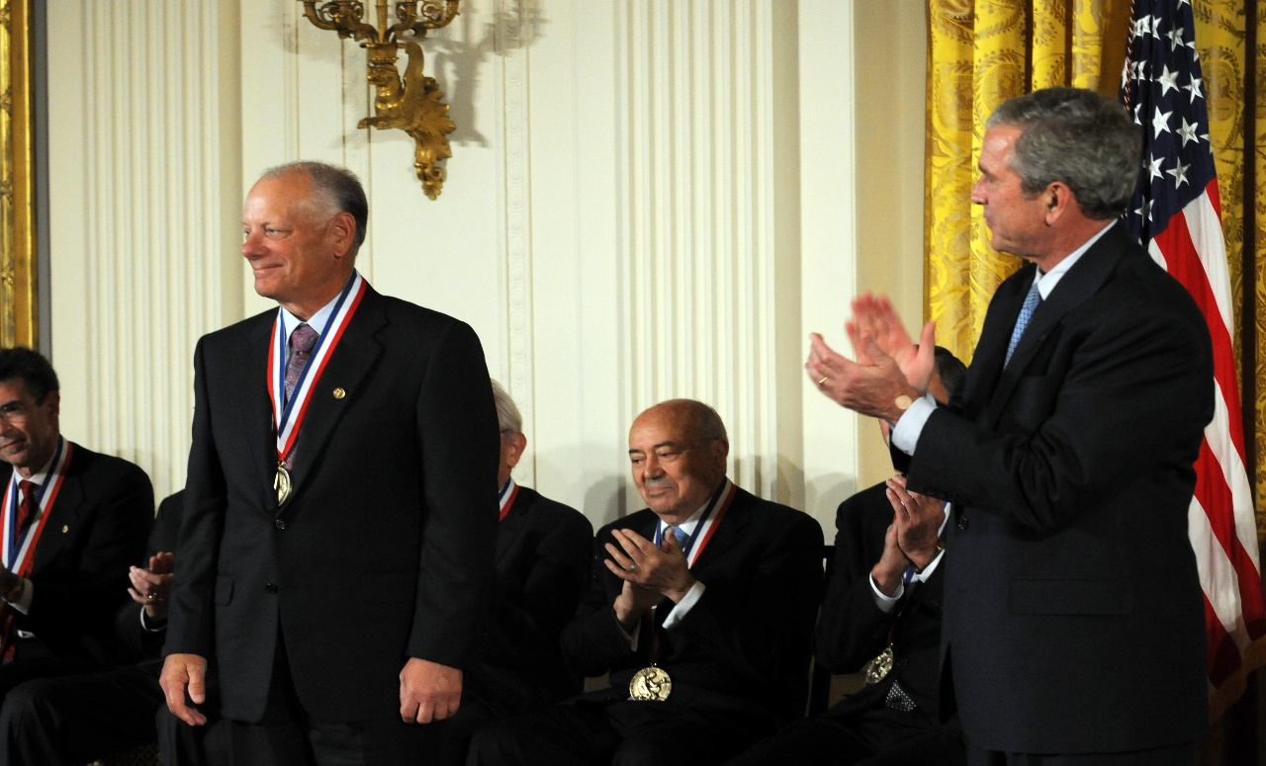

Cutler was honored at a White House ceremony in 2008 as one of the nation's National Medal of Technology and Innovation Laureates. Cutler is an affiliate faculty in the computer science department at the University of Washington and a member of the National Academy of Engineering. In April 2016, Cutler was honored as a Computer History Museum fellow at the Computer History Museum in Mountain View, California.

Dave Cutler’s legacy cannot be overstated. He is an indispensable software engineer who has made a massive impact on the computing experiences of billions of individuals and hundreds of thousands of businesses worldwide. The NT operating system is the basis of all Microsoft operating systems. When I turn on my laptop every day, I am experiencing the legacy of Cutler's innovative work. Cutler has had a huge impact on software engineering, computers and technology in general through his work. His tough standards and untiring work left a lasting impression on me.